UrbanSense–Citizen-Driven Micro-Climate & Air Quality Monitoring Platform

DIPTI DESHMUKH | KAJAL MAURYA | ARYMAN SINGH

PROF. AMOL RINDHE

Introduction :
In our fast-growing cities, dirty air has become a sneaky problem that hurts our health and our world. With more cars, buildings going up, and factories working, it's more important than ever to keep a close eye on the air we breathe. But most ways of checking air quality only cover certain areas or cost too much to use everywhere.
UrbanSense is a new approach that lets everyone in the community help monitor our local weather and air quality. It's all about giving people easy access to real-time info about what's going on around them. We want to make air quality monitoring something anyone can do, something useful, and something that focuses on the specific areas where people live, so individuals and communities can make smarter choices about their well-being and their environment.

Rationale :
Often, the air quality info we get isn't very specific – it doesn't tell you what the air is like right now on your street. UrbanSense solves this by using simple, affordable sensors, smart ways of processing the data, and getting the whole community involved.Our system lets ordinary people take part in monitoring the environment by using small sensor kits or even their phones. The information they gather isn't just shown on a simple dashboard; it's also analyzed using smart computer programs that can spot unusual patterns, guess what the air will be like in the future, and even send personalized warnings to people who might be extra-sensitive to pollution.

Methodolgy :
To make UrbanSense work – this community-based system for keeping an eye on our local weather and air – we're following a step-by-step plan. Each step is designed to be affordable, accurate, easy for everyone to use, and able to provide up-to-the-minute insights.

Step 1: Building the Sensors:

Here, we're focused on creating a small, inexpensive device that can measure different things in our environment, like:
1) Tiny particles in the air (PM2.5 and PM10)
2) Pollutant gases (CO₂ and NO₂)
3) How hot or humid it is
4) How loud it is (to measure noise pollution in cities)
To make sure we get good data, we're including:
- A mini-computer (like NodeMCU or ESP32) that can connect to Wi-Fi or Bluetooth.
- Sensors that measure the things we listed above (like SDS011 for particles, DHT22 for temperature/humidity).
- A GPS chip to track where the sensor is located.
- A design that saves energy so the sensor can run outdoors for a long time.

We're also checking the sensors against official data from nearby air quality stations to make sure they're accurate.

Step 2: Collecting and Understanding the Data:

Once the sensor is working, it sends data to a computer system in the cloud. In this step:
1) We store the data safely using services like Firebase, ThingSpeak, or MongoDB.
2) We clean up the data by removing errors and filling in any missing information.
3) We use a smart computer program to:
A) Spot any sudden spikes in pollution.
B) Guess what the air quality will be like based on past trends and the weather.
C) Fine-tune our inexpensive sensors to match the accuracy of more reliable equipment.

This helps our system get better over time, learn from the community's data, and make more accurate predictions.

Step 3: Creating the App and Dashboard:

This step is all about making things easy for users. We're building an app and a website that work on different devices, with features like:
1) A map that shows real-time air quality and weather based on where you are.
2) Suggestions for routes that avoid polluted areas.
3) Personalized alerts for people with breathing problems or who are sensitive pollution.
4) A way for people in the community to get rewards for contributing data.

The app can also store data offline and automatically update when you have an internet connection, so you can use it even if you're in an area with weak service.

Step 4: Testing, Getting Feedback, and Making Sure It Works:

To make sure everything is reliable and can handle lots of users, we're doing lots of testing in different areas:

1) We're checking to make sure the data is consistent, the sensors are reliable, and the app is easy to use.

2) We're creating different air quality situations (like heavy traffic, rain, construction) to see how well the system performs.

3) We're getting feedback from people who know about technology and people who don't, to make the system even better.

4) We're comparing our sensor data with official data (like from CPCB, AQI India) to make sure it's accurate.
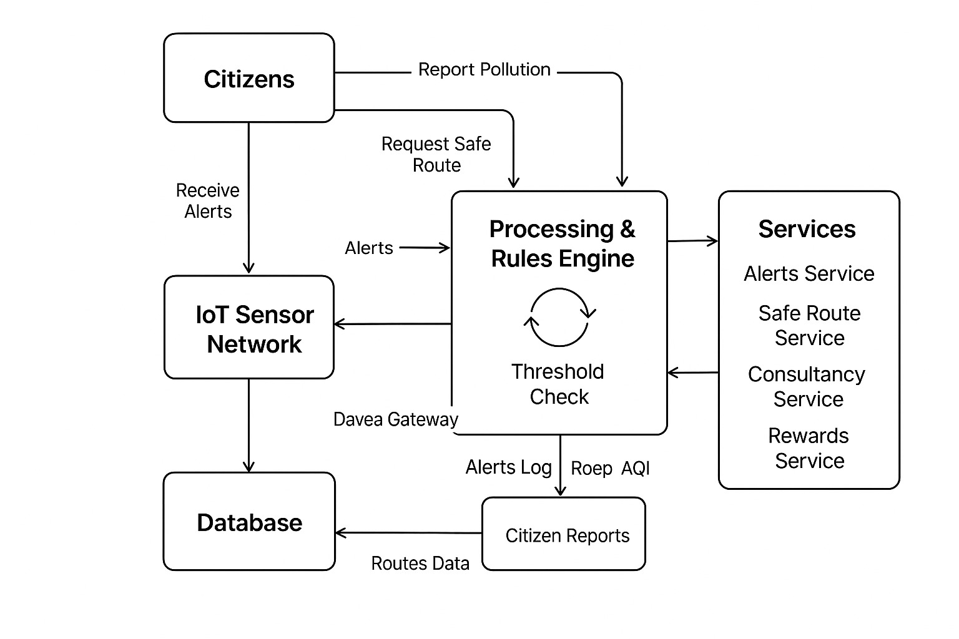

Expected Outcome :

UrbanSense aims to be a simple, community-powered way to monitor our local air quality and weather. We expect to see:

1) Accurate measurements of things like particles in the air, CO₂, temperature, and humidity.
2) Smarter data analysis and pollution predictions thanks to AI.
3) Personalized alerts to protect people who are vulnerable to air pollution.
4) An easy-to-use app with real-time maps and suggestions for clean routes.
5) More community involvement through rewards and awareness campaigns.
6) Useful data for city planners and local governments to make better decisions.
7) A system that can be expanded to other cities or smart environments.

All of this will help us breathe cleaner air, live healthier lives, and create smarter cities.

